Literature Review of Wheeled Inverted Pendulum System

Based on : Ri, S., Huang, J., Wang, Y., Kim, M., & An, S. (2014). **Terminal sliding mode control of mobile wheeled inverted pendulum system with nonlinear disturbance observer**. *Mathematical Problems in Engineering*, 2014.

Erivelton Gualter dos Santos  
[erivelton.gualter@gmail.com](mailto:erivelton.gualter@gmail.com)

Cleveland State University

Statement of Contribution — In this paper the authors present a Nonlinear Robust Control based on the Terminal Sliding Mode Controller (TSMC) technique which boosts the classical Sliding Mode Control with a nonlinear function in order to guarantee convergence of zero tracking error at the sliding surface in finite time. Furthermore, it is derived a Nonlinear Disturbance Observer to estimate the equivalent disturbance generated by human movement in the mobile wheeled inverted pendulum system and disturbances generated by modeling errors. Additionally, in order to verify the proposed method, I additionally implemented the methods for a unicycle with human driver disturbance in this paper using Matlab as well.

# Introduction

Transportation has been one of the most challenging topics in the field of engineering, especially in big cities where there is high demand, for fast, safe, and low cost transportation. The Mobile Wheeled Inverted Pendulum system, also known as unicycle, Segway and other nominations, is composed by only one powered wheel and a frame where a person can sit and ride away. The unicycle system can be modeled as a wheeled inverted pendulum as shown in Figure (1) and Figure (2), where the pendulum represents the frame and the person’s body.

The wheeled pendulum is classified as a nonlinear system since the relationship between the internal states is governed by trigonometric functions. The wheeled inverted pendulum is also classified as an underactuated system; it means the number of degrees of freedom of the system is higher than the number of control inputs. These two main characteristics transform the one wheel one-link inverted pendulum control problem in a nontrivial task.

Most of the control literature makes use of a clever assumption to simplify the nonlinear system, which is the fact that since the control task is to maintain the pendulum upwards, if one considers the control input is performing well, such as there are very small variations in the pendulum angle. Then a linearization of the system around the “upwards” fixed point is reasonable. Assuming this strategy is convenient, one can apply the Linear Quadratic Regulator (LQR) and all linear classic control techniques. The problem with this approach is that if the pendulum angle becomes higher due to an initial condition or external disturbances, the LQR may not work as intended. Another issue is that classic LQR is not a robust controller in the sense that it may fail in the presence of modeling uncertainties.

The goal of the paper is to design a robust controller to the wheeled pendulum system by means of the terminal sliding mode control (TSMC) technique that enables disturbance rejection and control of the unicycle system even in the presence of modeling errors. Between the design requirements, it is taking into account chattering reduction and tracking error convergence in finite time.

# System Modelling

The dynamics of a human riding a MWIP is simplified to a wheeled pendulum system with two degrees of freedom, where the center of mass of the pendulum is represented by the equivalent center of mass of the human body and the unicycle frame.

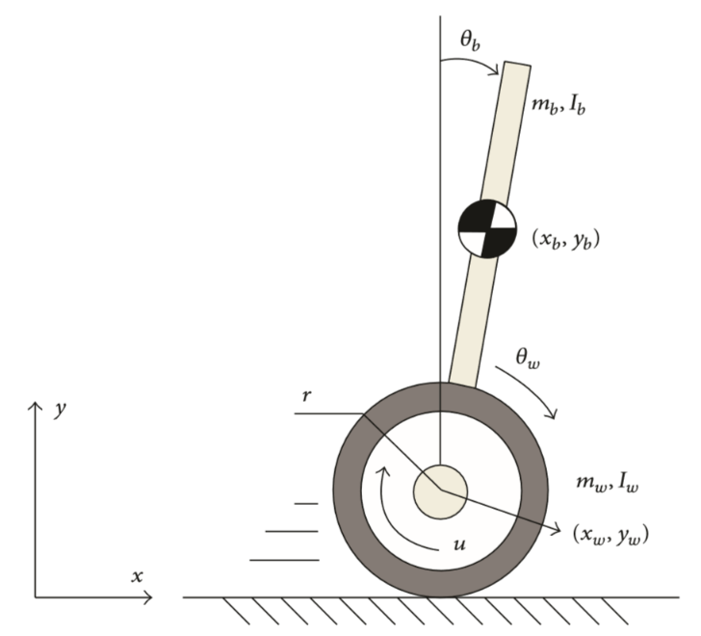

Figure 1 – Mobile wheeled inverted pendulum (MWIP) system model..

| Nomenclature | |
| --- | --- |
| $$m_{b},m_{ω}$$ | Masses of the body and the wheel |
| $$I_{b},I_{ω}$$ | Moments of inertia of the body and the wheel |
| $$l$$ | Length between the wheel axle and the center of gravity of the body |
| $$r$$ | Radius of the wheel |
| $$D_{b}$$ | Viscous resistance in the driving system |
| $$D_{ω}$$ | Viscous resistence of the ground |
| $$τ$$ | Input torque at the wheel |
| $$τ_{ext}$$ | External disturbance applied to the system |

Table 1 – Model Parameters

The equations of motion of the Wheeled Inverted Pendulum were obtained using Lagrangian Dynamics, and the result is shown in matrix form in equation (1). Full derivation is available in [3].

The term $τ_{ext}$ represents the external disturbances that can be originated from driver movement, wind, and other sources.

$$M\left(q\right)\ddot{q}+N\left(q,\dot{q}\right)+F\left(\dot{q}\right)=τ+τ_{ext}$$

where

$q={[q_{1 }q_{2}]}^{T}={[θ_{ω }θ_{b}]}^{T}$,

$M\left(q\right)= \left[\begin{matrix}m_{11} & m_{12}cos⁡(q_{2}) \\ m_{11}+m_{12}cos⁡(q_{2}) & m_{22}+m_{12}cos⁡(q_{2})\end{matrix}\right]$,

$N\left(q,\dot{q}\right)$ = $\left[\begin{matrix}-m_{12}{\dot{q_{2}}}^{2}sin⁡(q_{2}) \\ -G_{b}\sin\left(q_{2}\right)-m_{12}{\dot{q_{2}}}^{2}sin⁡(q_{2})\end{matrix}\right]$,

$F\left(\dot{q}\right)=\left[\begin{matrix}\left(D_{ω}+D_{b}\right)\dot{q_{1}}-D_{b}\dot{q_{2}} \\ -G_{b}\sin\left(q_{2}\right)-m_{12}{\dot{q_{2}}}^{2}sin⁡(q_{2})\end{matrix}\right]$,

$τ=\left[\begin{matrix}u \\ 0\end{matrix}\right]$, $τ_{ext}=\left[\begin{matrix}τ_{ex} \\ 0\end{matrix}\right]$.

The parameters $m_{11}$, $m_{12}$, $m_{22}$, and $G_{b}$ satisfy

$$m_{11}=\left(m_{b}+m_{ω}\right)r^{2}+I_{ω},$$

$$m_{12}=m_{b}lr,$$

$$m_{22}=m_{b}l^{2}+I_{b},$$

$$G_{b}=m_{b}gl$$

# Disturbance Observer Design

The control strategy adopted in the paper requires the development of a disturbance observer. First, the equivalent disturbance is computed as the sum of the contributions of the external disturbances and all modelling uncertainties.

The disturbance observer ${\hat{τ}}_{d}$ is a dynamical system designed to estimate the equivalent disturbance given torque input $u$ and state measurements $[q \dot{q}]$.

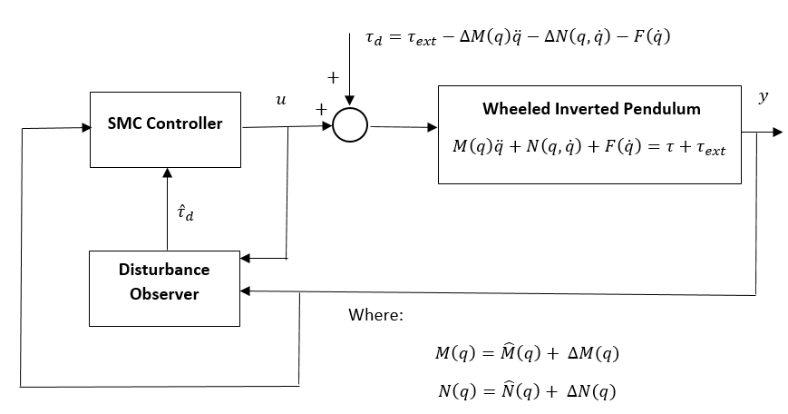

Figure 3 – The control strategy

The parameter uncertainties are modeled as follows

$M\left(q\right)=\hat{M}\left(q\right)+ ∆M(q)$,

$N\left(q,\dot{q}\right)=\hat{N}\left(q,\dot{q}\right)+ ∆N\left(q,\dot{q}\right)$.

The equivalent disturbance vector $τ_{d}$ is defined as,

$$τ_{d}={[τ_{d1} τ_{d2}]}^{T}=τ_{ext}-∆M\left(q\right)\ddot{q}-∆N\left(q,\dot{q}\right)-F\left(\dot{q}\right),$$

and the wheeled inverted pendulum dynamical system can be reduced to the formulation expressed in equation (7).

$$\hat{M}\left(q\right)\ddot{q}+\hat{N}\left(q,\dot{q}\right)=τ+τ_{d}$$

To estimate the equivalent disturbance $τ_{d}$, a nonlinear disturbance observer ${\dot{\hat{τ}}}_{d}$ is designed as follows,

$${\dot{\hat{τ}}}_{d}=-L(q){\hat{τ}}_{d}+L(q)(\hat{M}\left(q\right)\ddot{q}+\hat{N}\left(q,\dot{q}\right)-τ)$$

If one define ${\tilde{τ}}_{d}$ = $τ_{d}-$ ${\hat{τ}}_{d}$, the equation (8) can be expressed as

$${\dot{\hat{τ}}}_{d}= L(q){\tilde{τ}}_{d}$$

Therefore,

$${\dot{\tilde{τ}}}_{d}={\dot{τ}}_{d}-L(q){\tilde{τ}}_{d}$$

Where $L(q)$ is the observer gain.

Generally, the derivative of the equivalent disturbance ${ τ}_{d}$ is not available a priori. In this paper, it is considered the disturbance varies slowly with respect to the dynamics of the system, hence it is reasonable to suppose that ${\dot{τ}}_{d}≅0$.

Therefore, it results in,

$${\dot{\tilde{τ}}}_{d}=-{\dot{\hat{τ}}}_{d}=-L(q){\tilde{τ}}_{d}$$

Let us introduce an auxiliary variable $z$ such that,

$$z={[z_{1 }z_{2}]}^{T}={\hat{τ}}_{d}-p(\dot{q})$$

Where the observer gain $L\left(q\right)$, and the gain $p(\dot{q})$ are constrained as follows:

$$L\left(q\right)=X{\hat{M}}^{-1}\left(q\right)$$

$$p\left(\dot{q}\right)=X\dot{q}$$

$$\frac{dp(\dot{q})}{dt}=L\left(q\right)\hat{M}\left(q\right)\ddot{q}$$

where

$X=\left[\begin{matrix}c_{1} & c_{2} \\ c_{3} & c_{4}\end{matrix}\right]$, $c_{1}≥0. i=1,2,3,4.$

Replacing variables from equations (8) and (13) in equation (12), it is possible to express the disturbance observer equations as follows:

$$\dot{z}=\left[\begin{matrix}{\dot{z}}_{1} \\ \dot{z_{2}}\end{matrix}\right]=L\left(q\right)[ \hat{N}\left(q,\dot{q}\right)-τ-p\left(\dot{q}\right)-z ]$$

$${\hat{τ}}_{d}=z+p(\dot{q})$$

Finally, the dynamic equations for the equivalent disturbance observer are obtained.

$$\dot{z}=\left[\begin{matrix}{\dot{z}}_{1} \\ \dot{z_{2}}\end{matrix}\right]=\frac{1}{\det\left(\hat{M}\right)}\left[\begin{matrix}c_{1} & c_{2} \\ c_{3} & c_{4}\end{matrix}\right]\left[\begin{matrix}{\hat{m}}_{22}+{\hat{m}}_{12}\cos\left(q_{2}\right) & -{\hat{m}}_{12}\cos\left(q_{2}\right) \\ -{\hat{m}}_{11}-{\hat{m}}_{12}\cos\left(q_{2}\right) & {\hat{m}}_{11}\end{matrix}\right]$$

$$\left\{\left[\begin{matrix}-{\hat{m}}_{12}{\dot{q_{2}}}^{2}sin⁡(q_{2}) \\ -{\hat{G}}_{b}\sin\left(q_{2}\right)-{\hat{m}}_{12}{\dot{q_{2}}}^{2}sin⁡(q_{2})\end{matrix}\right]-\left[\begin{matrix}u \\ 0\end{matrix}\right]-\left[\begin{matrix}c_{1} & c_{2} \\ c_{3} & c_{4}\end{matrix}\right]\left[\begin{matrix}\dot{q_{1}} \\ \dot{q_{2}}\end{matrix}\right]-\left[\begin{matrix}z_{1} \\ z_{2}\end{matrix}\right]\right\}$$

$${\hat{τ}}_{d}=\left[\begin{matrix}{\hat{τ}}_{d1} \\ {\hat{τ}}_{d2}\end{matrix}\right]=\left[\begin{matrix}z_{1} \\ z_{2}\end{matrix}\right]+\left[\begin{matrix}c_{1} & c_{2} \\ c_{3} & c_{4}\end{matrix}\right]\left[\begin{matrix}\dot{q_{1}} \\ \dot{q_{2}}\end{matrix}\right]$$

It can be observed that a nonlinear robust disturbance observer was achieved. It depends on parameters estimated from the original system, tuning parameters $X$, and it also depends on control input $u$.

# Terminal Sliding Mode Controller Design

One of the disadvantages of the classic Sliding Mode Control (SMC) technique is that for some classes of dynamical systems it may not converge the tracking errors on sliding surface $s\left(t\right)$ to zero in finite time.

Terminal Sliding Mode Control (TSMC) is a variation of SMC, where the sliding surface $s\left(t\right)$ is defined with additional nonlinear terms, which leads tracking errors on sliding surface $s\left(t\right)$ to converge to zero in finite time. Furthermore, the TSMC nonlinear function can designed to reduce chattering and speed up convergence.

The pendulum angular acceleration ${\ddot{θ}}_{b}$, can be expressed as shown in equation (16).

$${\ddot{q}}_{2}={\ddot{θ}}_{b}=\frac{1}{\det\left(\hat{M}\right)}[{\hat{m}}_{11}{\hat{G}}_{b}\sin\left(q_{2}\right)-{\hat{m}}_{12}{\dot{q_{2}}}^{2}\sin\left(q_{2}\right)\cos\left(q_{2}\right)-\left({\hat{m}}_{11}+{\hat{m}}_{12}\cos\left(q_{2}\right)\right)u + {\hat{m}}_{11}τ_{d2}-({\hat{m}}_{11}+ {\hat{m}}_{12}\cos\left(q_{2}\right))τ_{d1} ]$$

$${\tilde{θ}}_{b}(t)=θ_{b}(t)-θ_{bdesired}(t)$$

$$q_{2}(t)=θ_{b}(t)$$

$$q_{d2}=θ_{bdesired}$$

The TSMC sliding surface $s\left(t\right)$ is defined as

$$s\left(t\right)={\dot{\tilde{θ}}}_{b}\left(t\right)+c_{smc}{\tilde{θ}}_{b}(t)-w\left(t\right), c>0$$

Where the nonlinear term $w\left(t\right)$ is a function of an augmented cubic polynomial function $v(t)$ introduced by Park in [2].

$$w\left(t\right)= \dot{v}\left(t\right)+c_{smc}v(t)$$

The augmenting function $v\left(t\right)$ was designed as a cubic polynomial as in [2].

$$v\left(t\right)=\left\{\begin{aligned}a_{0}+a_{1}t+a_{2}t^{2}+a_{3}t^{3}, if 0≤t≤T_{f} \\ 0, if t>T_{f}\end{aligned}\right.$$

where

$a_{0}$ = $θ_{b}(t)$, $a_{1}$ = $\dot{θ_{b}}(t)$

$a_{2}=-3\left(\frac{a_{0}}{T_{f}^{2}}\right)-2\left(\frac{a_{1}}{T_{f}}\right)$,

$a_{3}=2\left(\frac{a_{0}}{T_{f}^{3}}\right)+\left(\frac{a_{1}}{T_{f}^{2}}\right)$,

In order to develop a bounded controller, disturbance error boundaries $d_{1}$ and $d_{2}$ are defined in equation (21).

${|\tilde{τ}}_{d1}|≤d_{1}$, ${|\tilde{τ}}_{d2}|≤d_{2}$

It is important to remember that $d_{1}$ and $d_{2}$ have to be previously known boundaries.

The Terminal Sliding Mode controller $u$ is defined by selecting a controller that forces the first time derivative of $s\left(t\right)$ to be zero.

$$\dot{s}\left(t\right)=0$$

Finally, a controller $u$ can be chosen in order to force the tracking error to be zero at $s\left(t\right)$ as fast as possible, and it can be done by control gain saturation, as shown in equation (23).

$u={\left({\hat{m}}_{11}+{\hat{m}}_{12}\cos\left(q_{2}\right)\right)}^{-1}[{\hat{m}}_{11}{\hat{G}}_{b}\sin\left(q_{2}\right)-{\hat{m}}_{12}{\dot{q_{2}}}^{2}\sin\left(q_{2}\right)\cos\left(q_{2}\right) + {\hat{m}}_{11}{\hat{τ}}_{d2}-\left({\hat{m}}_{11}+ {\hat{m}}_{12}\cos\left(q_{2}\right)\right){\hat{τ}}_{d1}+\det\left(\hat{M}\right)\left(c_{smc}\dot{q_{2}}-\ddot{v}-c_{smc}\dot{v}\right)+Ksat(s)]$ (24)

Here $sat(s)$ is chosen in place of $sgn\left(s\right)$ in order to reduce chattering. The saturation happens when the tracking error at the sliding surface $s$ is higher then a defined limit boundary $ϕ$.

$$sat\left(s\right)=\left\{\begin{aligned}sgn\left(s\right), if \left|s\right|>ϕ, \\ \frac{s}{ϕ}, if \left|s\right|≤ϕ,\end{aligned}\right.$$

$ϕ>0$,

The gain K is constrained by the sliding condition show in equation (26).

$$s\dot{s}≤ -γ|s|$$

Using equation (26), K can be chosen as shown in equation (27)

$$K=γ+\left[{\hat{m}}_{11}d_{2}+\left({\hat{m}}_{11}+{\hat{m}}_{12}\cos\left(q_{2}\right)\right)d_{1}\right], γ>0$$

It possible to observe that the proposed controller makes the internal state $\dot{q_{1}}\left(t\right)=\dot{θ_{ω}}(t)$ also decays to zero.

The first row of equation (1) can be written as shown in equation (29).

For simplicity, the right hand side $RHS(t)$ of the first row of equation (1) is compressed by this term.

[$m_{11}+m_{12}cos⁡(q_{2}(t))]\dot{q_{1}}(t)+D_{ω}{\ddot{q}}_{1}(t)=RHS(t)$

[$m_{11}+m_{12}cos⁡(q_{2}(t))]>0$

$$D_{ω}>0$$

Since $q_{2}(t)$ and $\dot{q_{2}}(t)$ decays to zero due to the control $u$ applied to the system. This makes $RHS\left(t\right)$ converges to zero asymptotically, therefore $\dot{q_{1}}(t)$ also converges to zero.

# Numerical Simulation

In order to evaluate the methods used in the paper, I developed a simulation using the plant, controller and the following parameters.

The chosen parameters are presented below in Table 2. The human body parameters were found in [6].

| Parameter | Value |
| --- | --- |
| $$m_{b}$$ | 78.2 kg |
| $${\hat{m}}_{b}$$ | 100 kg |
| $$m_{ω}$$ | 7 kg |
| $${\hat{m}}_{ω}$$ | 7 kg |
| $$I_{b}$$ | 66 kg/m^2 |
| $${\hat{I}}_{b}$$ | 84.6045 kg/m^2 |
| $$I_{ω}$$ | 0.1445 kg/m^2 |
| $${\hat{I}}_{ω}$$ | 0.1445 kg/m^2 |
| $$l$$ | 0.87 m |
| $$\hat{l}$$ | 0.7 m |
| $$r$$ | 0.203 m |
| $$D_{b}$$ | 0.1 |
| $$D_{ω}$$ | 4 |
| $$c_{1}$$ | 2000 |
| $$c_{2}$$ | 0 |
| $$c_{3}$$ | 0 |
| $$c_{4}$$ | 2000 |
| $$d_{1}$$ | 1 Nm |
| $$d_{2}$$ | 6 Nm |
| $$ϕ$$ | 0.01 |
| $$T_{f}$$ | 0.5 s |
| $$c_{smc}$$ | 6 |
| $$γ$$ | 3 |
| $$g$$ | 9.81 m/s^2 |

Table 2 – Simulation Parameters

The dynamical system was written in the state space form as shown in equations (30) and (31).

$$\left[\begin{matrix}x_{1} \\ x_{2} \\ \begin{matrix}x_{3} \\ x_{4}\end{matrix}\end{matrix}\right]=\left[\begin{matrix}q_{1} \\ q_{2} \\ \begin{matrix}\dot{q_{1}} \\ \dot{q_{2}}\end{matrix}\end{matrix}\right]=\left[\begin{matrix}θ_{ω} \\ θ_{b} \\ \begin{matrix}\dot{θ_{ω}} \\ \dot{θ_{b}}\end{matrix}\end{matrix}\right]$$

$$\left[\begin{matrix}\dot{x_{1}} \\ \dot{x_{2}} \\ \begin{matrix}\dot{x_{3}} \\ \dot{x_{4}}\end{matrix}\end{matrix}\right]=\left[\begin{matrix}\dot{q_{1}} \\ \dot{q_{2}} \\ \begin{matrix}\ddot{q_{1}} \\ \dot{q_{2}}\end{matrix}\end{matrix}\right]=\left[\begin{matrix}\dot{θ_{ω}} \\ \dot{θ_{b}} \\ \begin{matrix}{\ddot{θ}}_{ω} \\ {\ddot{θ}}_{b}\end{matrix}\end{matrix}\right]$$

The external disturbance applied to the system $τ_{ex}$ was defined in this simulation as shown in equation (32).

$$τ_{ex}=\frac{1}{3}m_{b}gl\sin\left(2t+\frac{π}{2}\right)[Nm]$$

And the initial state conditions are shown in equation below

$$\left[\begin{matrix}x_{1_{0}} \\ x_{2_{0}} \\ \begin{matrix}x_{3_{0}} \\ x_{4_{0}}\end{matrix}\end{matrix}\right]=\left[\begin{matrix}0 \\ -0.1745 \\ \begin{matrix}0 \\ 0\end{matrix}\end{matrix}\right]$$

The simulation results are shown below.

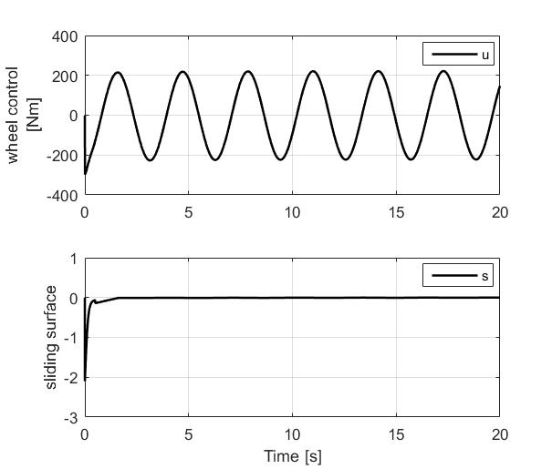

Figure 4 – Time response of control input u, and the sliding surface s.

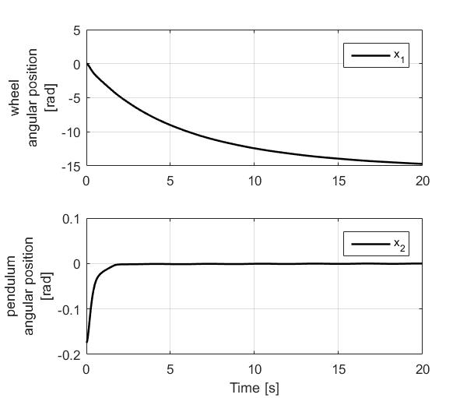

Figure 5 – Time response of wheel angular position and pendulum angular position.

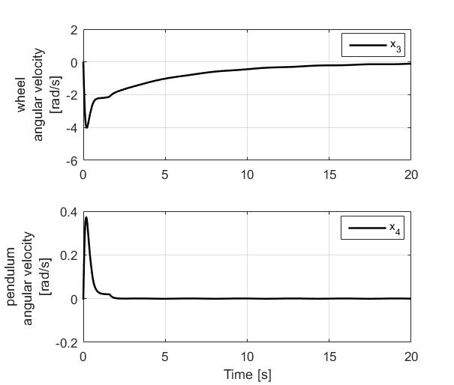

Figure 6 – Time response of wheel angular velocity and pendulum angular velocity.

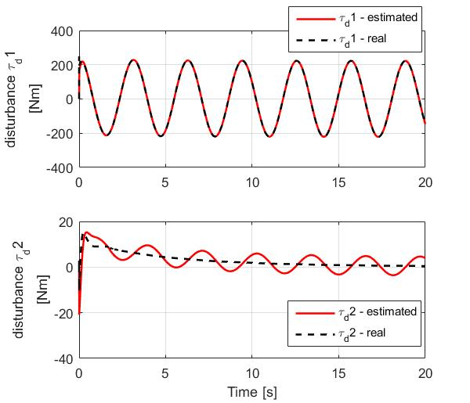

Figure 7 – Time Response of the estimated disturbances provided by the nonlinear disturbance observer observer system compared to the real equivalent disturbance.

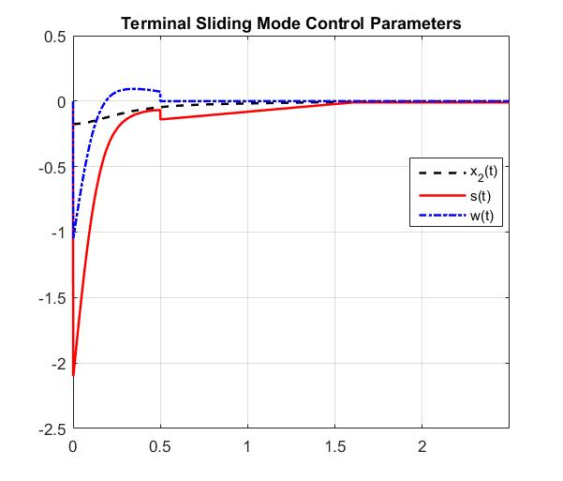

Figure 8 – Time response of pendulum position angle x2, sliding surface s, and nonlinear terminal function w(t)

# **Results Discussion**

As in the reviewed paper and the new simulation I presented here, the controller *u* is compensating the equivalent disturbances $τ_{d}$, and drove the states $x_{1},x_{2},$ and $x_{3}$ to zero.

In special, the Terminal Sliding Mode Control technique was applied successfully since the controller u was able to drive the system within the relaxation time $T_{f}=0.5$ due to the nonlinear term w(t). After the relaxation time $T_{f}$, the control u forced the error at the sliding surface s to decrease linearly, reaching the maximum permissible error of $ϕ/c_{smc}$ = 0.01/6=0.016 in about 1.6s as shown in Figure 8.

It is also possible to see that disturbance observer was able to present good estimates of the controller was able to have good performance even in the presence of $τ_{d1}$ with error very close to zero in finite time, but it estimated $τ_{d2}$ with low error accuracy. It was possible to verify that low external disturbances lead to high accuracy estimates for both $τ_{d1}$ and $τ_{d2}$, therefore tuning the observer parameters probably can provide better estimation results. Surprisingly, even in the presence of error estimates the controller was able to maintain its robustness, and compensate and control the system according all design specifications.

# **Conclusion**

The unicycle system was presented in this paper as a useful mean of transportation, and the dynamic model of the system was derived as a wheeled inverted pendulum, which is a nontrivial and complex control problem. Furthermore, in this paper it was considered that the system is subjected to modelling uncertainties and high external disturbances.

A nonlinear disturbance observer was developed to estimate the equivalent disturbance, and it was one of the parameters which composed the Terminal Sliding Mode Controller.

The Terminal Sliding Mode Controller in conjunction with the Nonlinear Disturbance Observer were able to show excellent results. This robust approach allows control of the wheeled inverted pendulum even in the presence of high disturbances and uncertainties, and it possible to verify that the TSMSC with the Nonlinear Observer can follow rigorous time and tracking error specifications.

##### **References**

1. SongHyok Ri, Jian Huang, Yongji Wang, Myong Ho Kim, and Sonchol An, “Terminal Sliding Mode Control of Mobile Wheeled Inverted Pendulum System with Nonlinear Disturbance Observer,” Hindawi Publishing Corporation, Volume 2014, Article ID 284216, September 2014.
2. Park KB, Tsuiji T. Terminal sliding mode control of second-order nonlinear uncertain systems, International Journal of Robust and Nonlinear Control, 1999, 9 (11): 769-780.
3. J. Huang, F. Ding, T. Fukuda, and T. Matsuno, “Modeling and velocity control for a novel narrow vehicle based on mobile wheeled inverted pendulum,” IEEE Transactions on Control SystemsTechnology,vol.21,no.5,pp.1607–1617,2013.
4. M. Zhihong, A. P. Paplinski, and H. R. Wu, “A robust MIMO terminal sliding mode control scheme for rigid robotic manipulators,”IEEE Transactions on Automatic Control,vol.39,no.12, pp.2464–2469,1994.
5. J.Wu,J.Huang,Y.Wang,andK.Xing,“Nonlinear disturbance observer-based dynamic surface control for trajectory tracking of pneumatic muscle system,” IEEE Transactions on Control Systems Technology , vol.22 , no.2, pp.440–455,2014.
6. Christoph Maurer, Robert J. Peterka, “A New Interpretation of Spontaneous Sway Measures Based on a Simple Model of Human Postural Control”, Journal of Neurophysiology Published 1 January 2005 Vol. 93 no. 1, 189-200 DOI: 10.1152/jn.00221.2004